USER MANUAL

User Manual for ModuleApp

Table of Contents

1. Introduction

2. System Requirements

3. Installation

4. Getting Started

5. Main Application

- 5.1. Module Management

- 5.2. Semester Management

- 5.3. Display Modules

- 5.4. Record Study Hours

- 5.5. Calculate Remaining Study Hours

6. Frequently Asked Questions (FAQs)

7. Contact Information

1. Introduction

Welcome to ModuleApp! ModuleApp is a program designed to help you manage your academic modules, record study hours, and calculate remaining self-study hours during a semester. This user manual will guide you through the installation process and provide step-by-step instructions on how to use the program effectively.

2. System Requirements

Before using ModuleApp, please ensure that your computer meets the following system requirements:

- Operating System: Windows 7 or later

- .NET Framework 4.7.2 or later

3. Installation

To install ModuleApp, follow these steps:

1. Download the ModuleApp installation package from the official website or a trusted source.

2. Run the installer and follow the on-screen instructions.

3. Once the installation is complete, ModuleApp will be ready to use.

4. Getting Started

To launch ModuleApp, double-click the desktop shortcut or search for "ModuleApp" in the Start menu.

5. Main Application

5.1. Module Management

In ModuleApp, you can manage your academic modules. Here's how to do it:

Adding a Module

1. Click on the "Module" tab in the main menu.

2. Click the "Enter New Module" button.

3. Enter the module details, including the name, code, credits, and class hours per week.

4. Click the "Save" button to add the module to your list.

Viewing Module List

1. Click on the "Module" tab in the main menu.

2. Click the "View Modules" button to see a list of all your modules.

5.2. Semester Management

ModuleApp allows you to manage your semesters. Here's how:

Adding a Semester

1. Click on the "Semester" tab in the main menu.

2. Click the "Add Semester" button.

3. Enter the number of weeks in the semester.

4. Enter the start date of the semester.

5. Click the "Enter" button to add the semester.

5.3. Display Modules

You can display your module details using the "Display Modules" feature:

1. Click on the "Display Modules" tab in the main menu.

2. Click the "Display" button to view your module details.

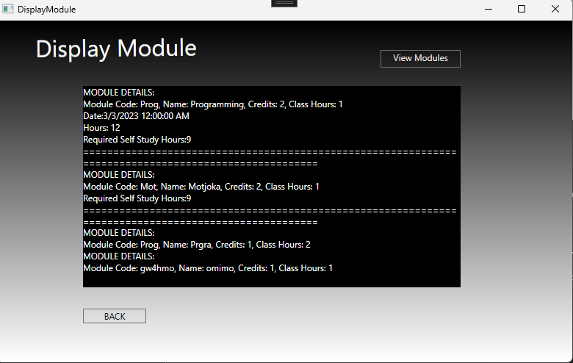

5.4. Record Study Hours

ModuleApp allows you to record your study hours for each module. Here's how:

1. Click on the "Record Study Hours" tab in the main menu.

2. Enter the module code for which you want to record study hours.

3. Enter the date and hours you've studied.

4. Click the "Save" button to record your study hours.

5.5. Calculate Remaining Study Hours

You can calculate and display your remaining self-study hours for each module using the "Calculate Remaining Study Hours" feature:

1. Click on the "Calculate Remaining Study Hours" tab in the main menu.

2. Click the "Search" button after entering a module code to find the module in the 'modules.txt' file.

3. Click the "Display" button to view the remaining self-study hours for the module.

6. Frequently Asked Questions (FAQs)

Q1: How can I delete a module?

To delete a module, go to the "Module" tab, click the "View Modules" button, select the module you want to delete, and click the "Delete" button.

Q2: Can I edit module details?

Currently, ModuleApp does not support editing module details after they have been added. You can delete the module and re-add it with updated details.

Q3: How can I export module or semester details?

ModuleApp does not have a built-in export feature. You can, however, manually copy and paste the details into a document or spreadsheet.

8. Contact Information

If you have any questions, feedback, or encounter issues with ModuleApp, please feel free to contact us at [support@moduleapp.com]

Thank you for using ModuleApp! We hope this user manual helps you effectively manage your academic modules, record study hours, and track your progress during your studies.